

Submitted By,
Name : Tasmia Hossain
ID : 20210204038
Section : A
Group : 1
Year/Semester : 4/1

Date of Submission : 23. 07. 2025
Submitted to ,
Saha Reno
Tahsina Muthaki
Course No : CSE 4142
Course Title : Data Warehousing and Mining Lab
Assignment 2
Department of Computer Science and Engineering
Ahsanullah University of Science and Technology

Introduction
In this assignment, the objective is to design and evaluate a classification model using the J48 decision tree algorithm in Weka. A custom dataset was created with 8 attributes, consisting of 4 numeric, 3 nominal, and 1 class attribute with 3 possible class values. The model was trained using 10-fold cross-validation, and one fold was extracted as a balanced test set to evaluate model performance.

Methodology
- Dataset Creation
A Dataset was created with 8 Attributes: 4 Numeric, 3 Nominal & 1 Class (3 Class Values).
@relation StudentDataset

@attribute Age numeric
@attribute Height numeric
@attribute Weight numeric
@attribute CGPA numeric
@attribute Gender {Male,Female}
@attribute Department {CSE,EEE,BBA}
@attribute Attendance {High,Medium,Low}
@attribute Result {Pass,Fail,Average}

- Instance Creation
30 instances were created with the following class distribution:
@data
22,165,55,3.8,Male,CSE,High,Pass
21,160,50,2.4,Female,EEE,Low,Fail
20,170,60,3.2,Female,BBA,Medium,Average
23,175,70,3.9,Male,CSE,High,Pass
19,168,52,3.5,Female,EEE,Medium,Pass
22,172,65,2.1,Male,BBA,Low,Fail
24,180,75,3.4,Male,CSE,Medium,Average
18,155,45,2.8,Female,EEE,Low,Fail
21,169,59,3.6,Male,BBA,High,Pass
20,162,52,2.9,Female,CSE,Medium,Average
23,177,69,3.95,Male,EEE,High,Pass
19,160,48,2.3,Female,BBA,Low,Fail
22,165,60,3.3,Male,CSE,Medium,Average
20,168,58,3.7,Female,EEE,High,Pass
24,173,67,2.2,Male,BBA,Low,Fail
21,169,55,3.1,Female,CSE,Medium,Average
23,176,72,3.85,Male,EEE,High,Pass
19,158,50,2.5,Female,BBA,Low,Fail
25,181,78,3.6,Male,CSE,High,Pass
20,163,56,3.0,Female,EEE,Medium,Average
21,168,60,3.4,Male,BBA,High,Pass
22,174,68,3.2,Female,CSE,Medium,Average
19,159,47,2.0,Female,EEE,Low,Fail
24,178,74,3.75,Male,BBA,High,Pass
23,165,58,3.1,Female,CSE,Medium,Average
20,162,52,2.3,Female,EEE,Low,Fail
22,170,62,3.5,Male,BBA,High,Pass
21,164,54,2.8,Female,CSE,Medium,Average
25,179,76,3.9,Male,EEE,High,Pass
18,156,48,2.1,Female,BBA,Low,Fail

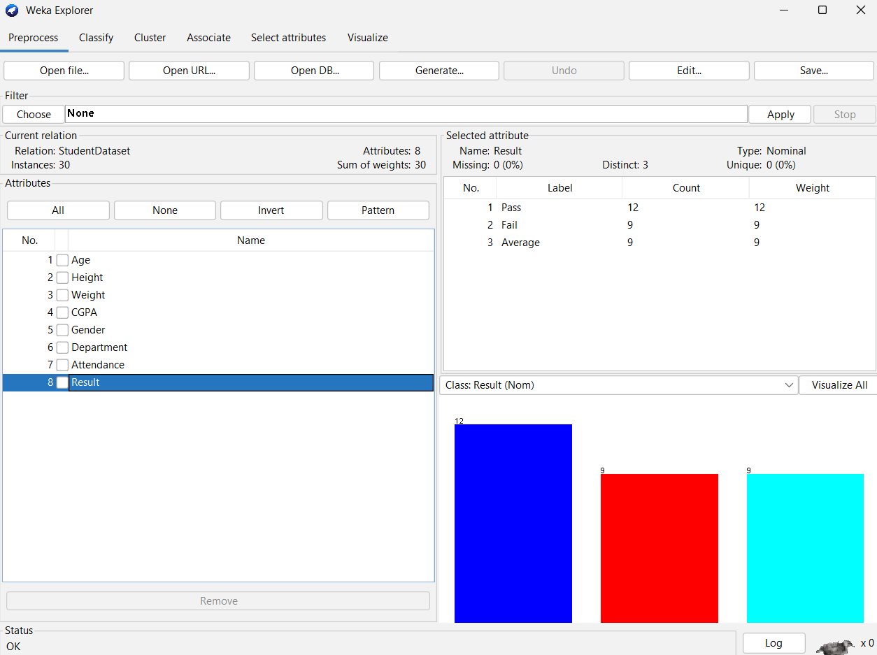
- Model Training using J48 with 10-Fold Cross Validation
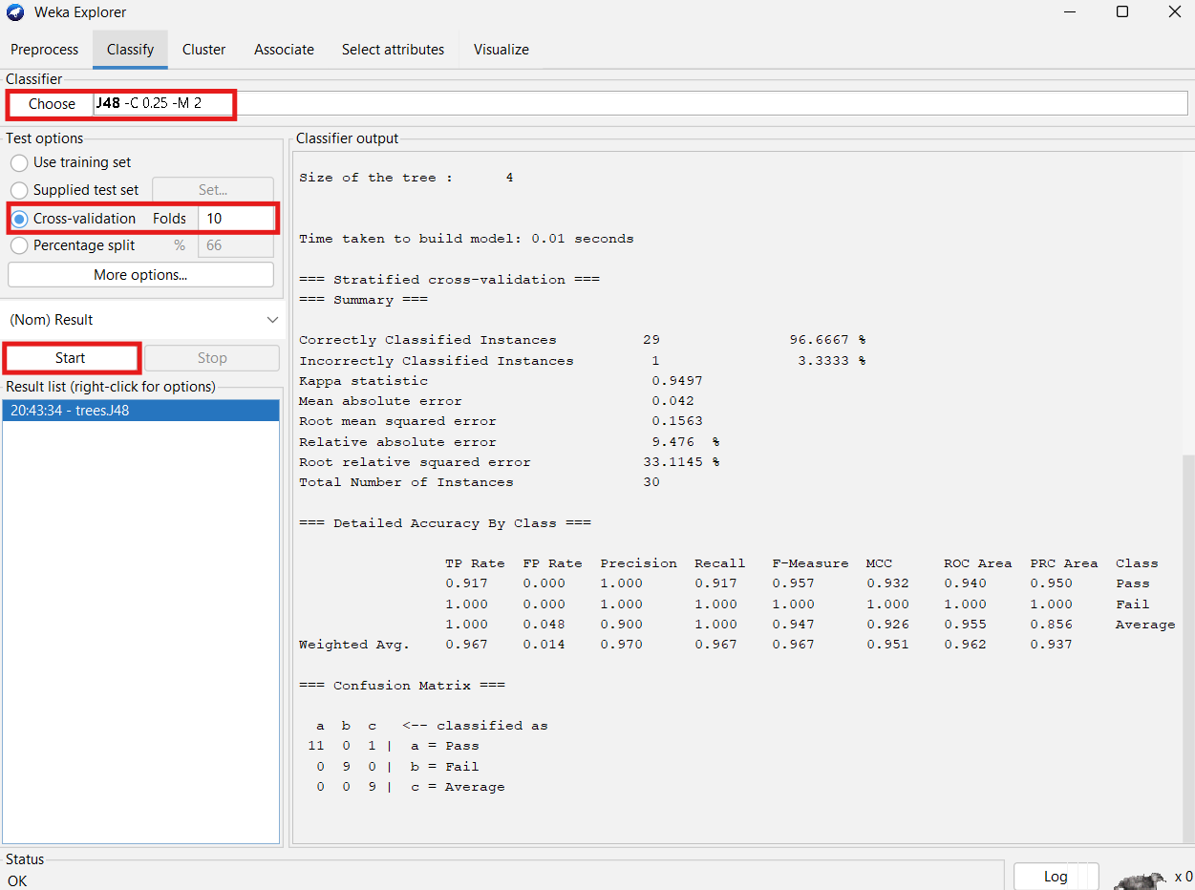
- Fold Extraction Using StratifiedRemoveFolds Filter
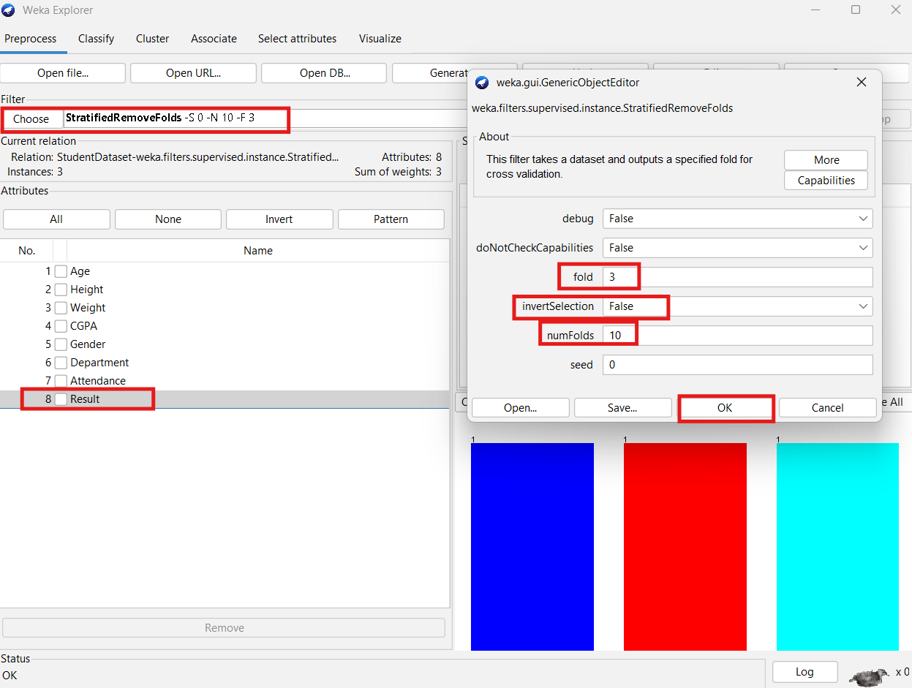
To simulate real-world testing, StratifiedRemoveFolds filter was used to extract fold 1 from the dataset.
Test Dataset:
@relation StudentDataset-weka.filters.supervised.instance.StratifiedRemoveFolds-S0-N10-F3

@attribute Age numeric
@attribute Height numeric
@attribute Weight numeric
@attribute CGPA numeric
@attribute Gender {Male,Female}
@attribute Department {CSE,EEE,BBA}
@attribute Attendance {High,Medium,Low}
@attribute Result {Pass,Fail,Average}

@data
19,168,52,3.5,Female,EEE,Medium,Pass
22,165,60,3.3,Male,CSE,Medium,Average
19,159,47,2,Female,EEE,Low,Fail

Modified Training Dataset:
@relation StudentDataset-weka.filters.supervised.instance.StratifiedRemoveFolds-S0-V-N10-F3

@attribute Age numeric
@attribute Height numeric
@attribute Weight numeric
@attribute CGPA numeric
@attribute Gender {Male,Female}
@attribute Department {CSE,EEE,BBA}
@attribute Attendance {High,Medium,Low}
@attribute Result {Pass,Fail,Average}

@data
22,165,55,3.8,Male,CSE,High,Pass
22,170,62,3.5,Male,BBA,High,Pass
21,164,54,2.8,Female,CSE,Medium,Average
23,175,70,3.9,Male,CSE,High,Pass
25,179,76,3.9,Male,EEE,High,Pass
24,173,67,2.2,Male,BBA,Low,Fail
21,169,59,3.6,Male,BBA,High,Pass
21,169,55,3.1,Female,CSE,Medium,Average
19,158,50,2.5,Female,BBA,Low,Fail
23,177,69,3.95,Male,EEE,High,Pass
24,180,75,3.4,Male,CSE,Medium,Average
18,155,45,2.8,Female,EEE,Low,Fail
20,168,58,3.7,Female,EEE,High,Pass
20,163,56,3,Female,EEE,Medium,Average
20,162,52,2.3,Female,EEE,Low,Fail
23,176,72,3.85,Male,EEE,High,Pass
22,174,68,3.2,Female,CSE,Medium,Average
22,172,65,2.1,Male,BBA,Low,Fail
25,181,78,3.6,Male,CSE,High,Pass
20,162,52,2.9,Female,CSE,Medium,Average
21,160,50,2.4,Female,EEE,Low,Fail
21,168,60,3.4,Male,BBA,High,Pass
23,165,58,3.1,Female,CSE,Medium,Average
19,160,48,2.3,Female,BBA,Low,Fail
24,178,74,3.75,Male,BBA,High,Pass
20,170,60,3.2,Female,BBA,Medium,Average
18,156,48,2.1,Female,BBA,Low,Fail
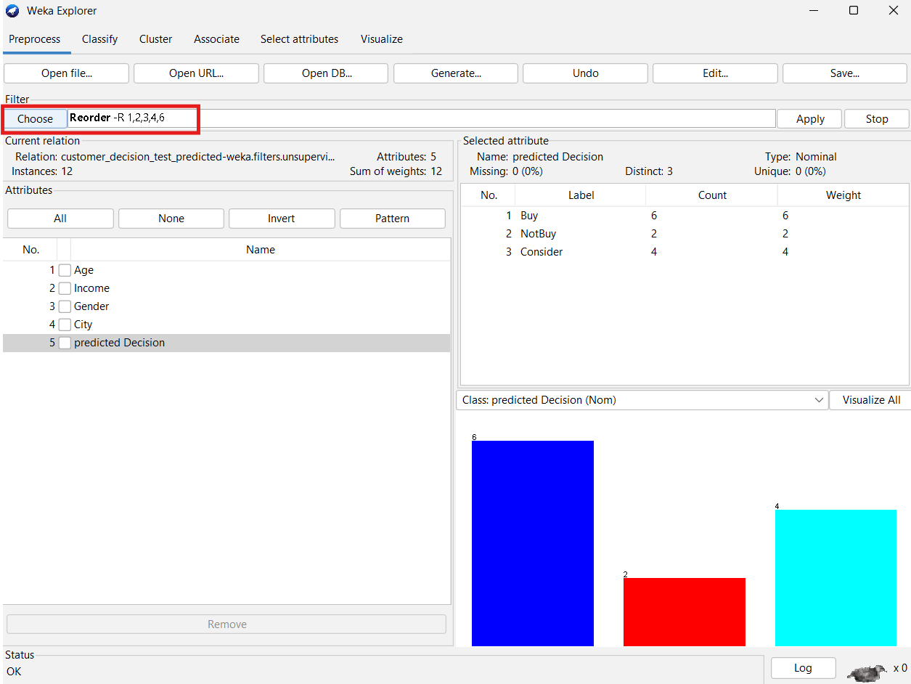

Modified Test Dataset with Predictions:

@relation 'customer_decision_test_predicted-weka.filters.unsupervised.attribute.Reorder-R1,2,3,4,6'

@attribute Age numeric
@attribute Income numeric
@attribute Gender {Male,Female}
@attribute City {Dhaka,Chittagong,Sylhet}
@attribute 'predicted Decision' {Buy,NotBuy,Consider}

@data
33,28000,Female,Dhaka,Buy
47,42000,Male,Chittagong,Consider
29,33000,Female,Sylhet,Buy
55,38000,Male,Dhaka,Consider
42,46000,Female,Chittagong,Buy
31,21000,Female,Sylhet,Buy
40,35000,Female,Sylhet,Buy
45,28000,Male,Chittagong,NotBuy
60,32000,Female,Sylhet,Consider
53,37000,Female,Dhaka,Consider
52,52000,Female,Chittagong,Buy
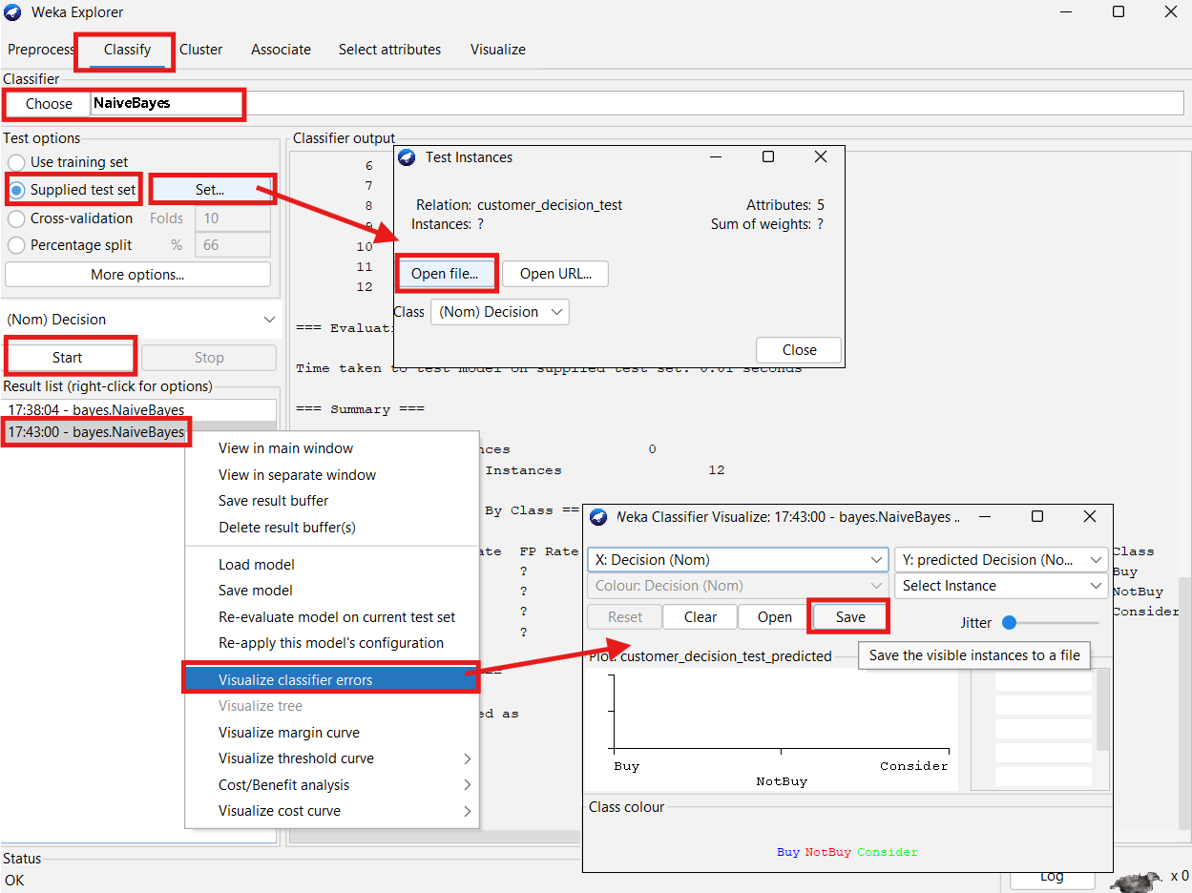
30,28000,Male,Sylhet,NotBuy
Result Analysis
The J48 decision tree classifier achieved perfect accuracy on the extracted test fold, correctly classifying all three instances representing each of the class labels (Pass, Fail, and Average). This demonstrates that the model was able to generalize well even when evaluated on a small, balanced, and previously unseen subset.
- The dataset was well-structured and diverse.
- Stratified fold extraction ensured class balance.
- J48 classifier effectively identified patterns in both nominal and numeric attributes.
- The model performance confirms accurate learning during training and effective generalization during testing.

Conclusion
This assignment provided hands-on experience in data preprocessing, fold-based validation, and classification model implementation using Weka. By constructing a custom dataset, applying stratified sampling, and building a J48 decision tree model, I gained practical knowledge in designing, training, and evaluating machine learning models. These techniques are vital for developing reliable predictive systems in real-world applications.

